Introduction:

Freehand Mx software is a vector – based drawing application. Freehand MX includes Vector effects such as bend, stretch and transform. It combines a wide range of drawing tools with special effects. Logo design is the combination of image and graphics in multimedia. And images can be in formats like JPEG, GIF, etc. Graphics formats are specified to graphics primitive and their attributes. There are mainly two types of graphics:
- Roster Graphics
- Vector Graphics
The main purpose of using it is to create different logos of colleges, schools, offices, etc.

Objectives:

- To create a logo using different tools available in Macromedia Freehand MX.
- To understand the use of different tools and be familiar with them.
- To be able to create different shapes of different sizes within the same or different designs.

Materials:

Software used: Macromedia Freehand MX.

Steps:

- Create a new project after opening the application by clicking on file from toolbar and then clicking on New Oregon just use ' Ctrl+N ' shortcut key.
- Select the 'rectangular tool' and draw a rectangle which is the outline of our bill.
- Use ‘Text tool’ to write in the bill like company name, order number, date, address, total amount, and contact.
- Format the text as per need like bold, italic, font size, font type, etc.
- Use the line tool or ‘Rectangular tool’ to draw a table on the bill.
- The table should consist of serial no, items, total quantity of items and amount of those items.
- Adjust the table and serial no, items, quantity, and all other components by aligning them in a proper way.
- A simple bill is created.

Shortcut Keys:
- Ctrl + N = Open new document.
- Ctrl + Shift + D = Clone.
- Alt + Shift = resize, shape without disturbing ratio of shapes.
- Ctrl + K = active keyline / de-active keyline.
- Ctrl + Shift + Y = Attach to path.
- Ctrl + Alt + R = Ruler.
- Ctrl + ‘+’ = Zoom In
- Ctrl + ‘-’ = Zoom Out
- Ctrl + Alt + A = Opens a align window to align objects.

Windows in Macromedia Freehand MX.
- Properties: Contains the Document panel and Object panel. Were,
  - Document Panel is where we can set page size and orientation.
  - Object panel shows the properties of selected objects.
- Tools: Contains many tools we will use to create custom art objects.
- Assets: Contains Swatches panels, Style panels & Library panels. Were,
  - Swatches panels are used to add, fill and stroke colors to a selected object.
- Layers: Used to organize objects, control stacking order, and manage visibility, making it easier to work with complex vector graphics by grouping elements and controlling their display.
- Mixer and Tints:
  - A mixer panel is used to create and adjust colors by blending or mixing different colors swatches together.
  - Tints panels are used to apply varying levels of transparency or opacity (tints) to objects in our design.
- View: Used for 'zoom in' and 'zoom out' and move the page.
- Colors: Allows us to select and adjust file and stroke colors for our objects. It provides options to mix colors using various color modes.
- Snap: Use to control objects alignment and snapping behavior.

Tools Used:
- Rectangle tool: To draw Rectangle Shape.
- Bucket and Strok tool: To fill color in shapes and manage strokes.
- Line Tool: To draw lines.
- Text Tool: To write text on our page.

Discussion and Analysis:
Macromedia Freehand MX is a great tool for vector-based drawing. It can be used for logo making, advertisement, banner making, bill making. we can use different and amazing tools which come to handy during our artwork creation.

Conclusion:
Logo and many other vector-based drawings can be created using Macromedia Freehand MX.
References:
- YouTube.
- Google.
- ChatGPT.

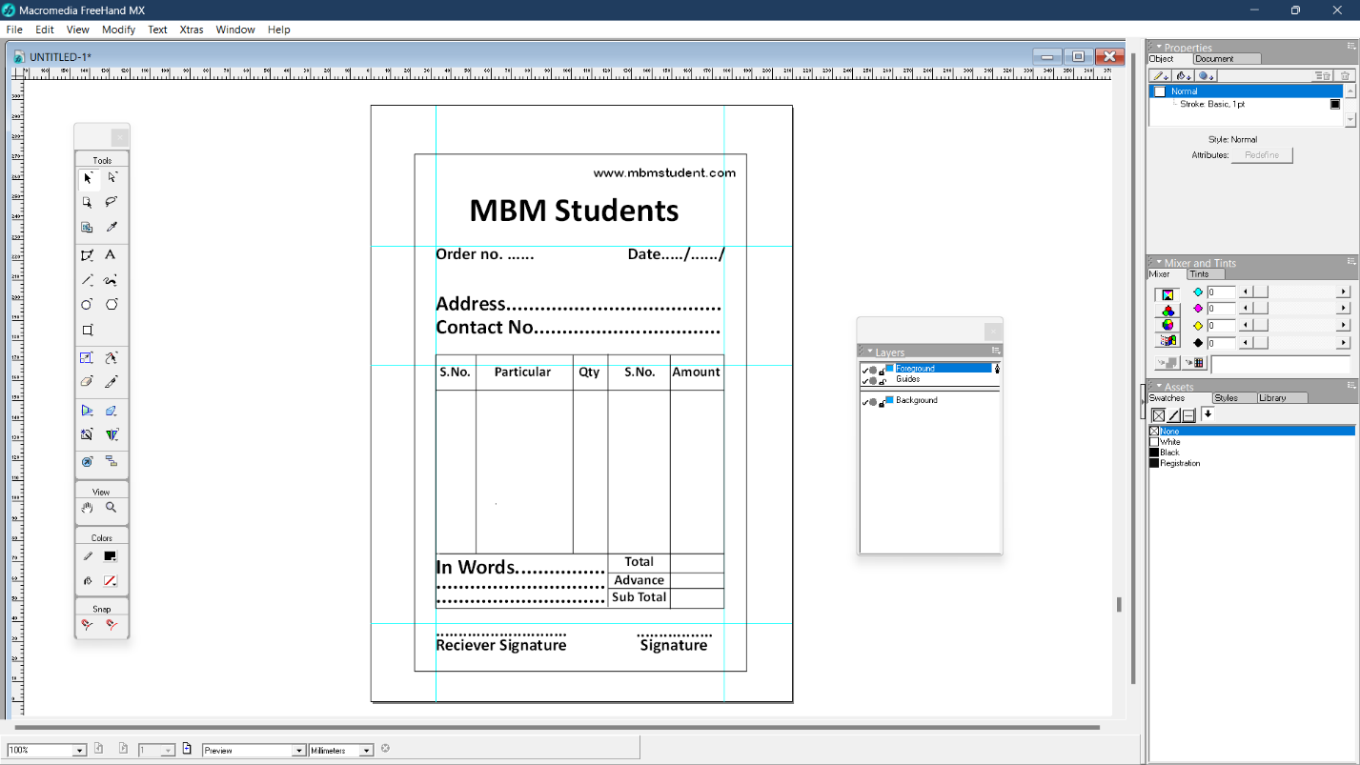
Simple Bill using Macromedia Freehand MX.

Final Bill Form
